Lab 4: Network Secure Proxy
Part 1 : Network Configuration
P1.1 screenshot
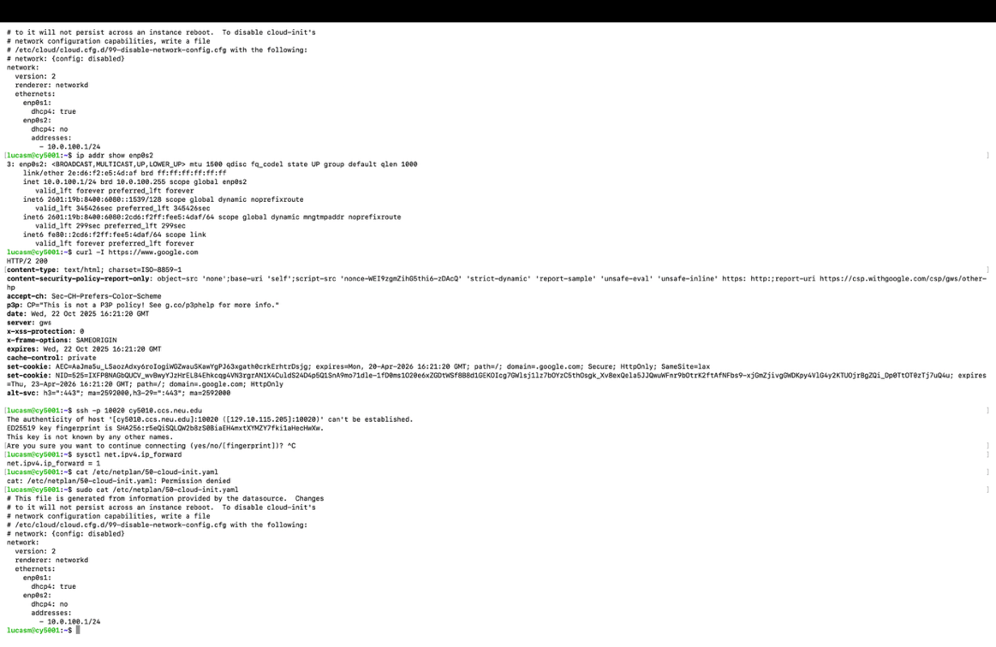
P1.2 screenshot
IPv4
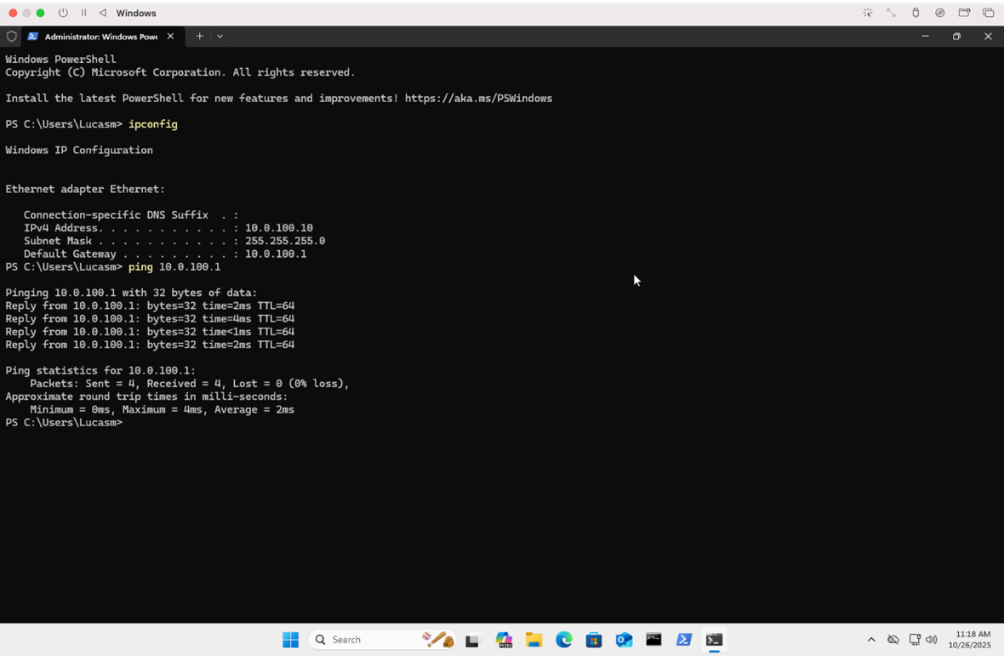
IPv6
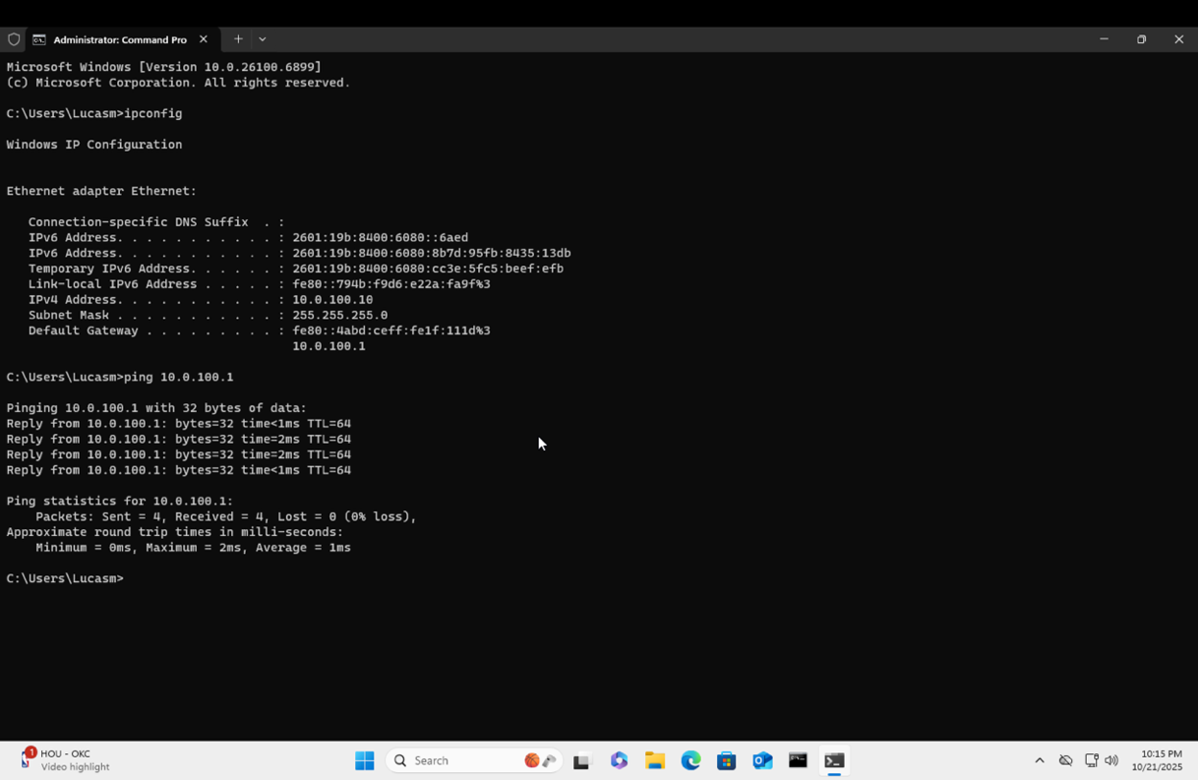

Part 2 - DNS Configuration
P2.1 screenshot
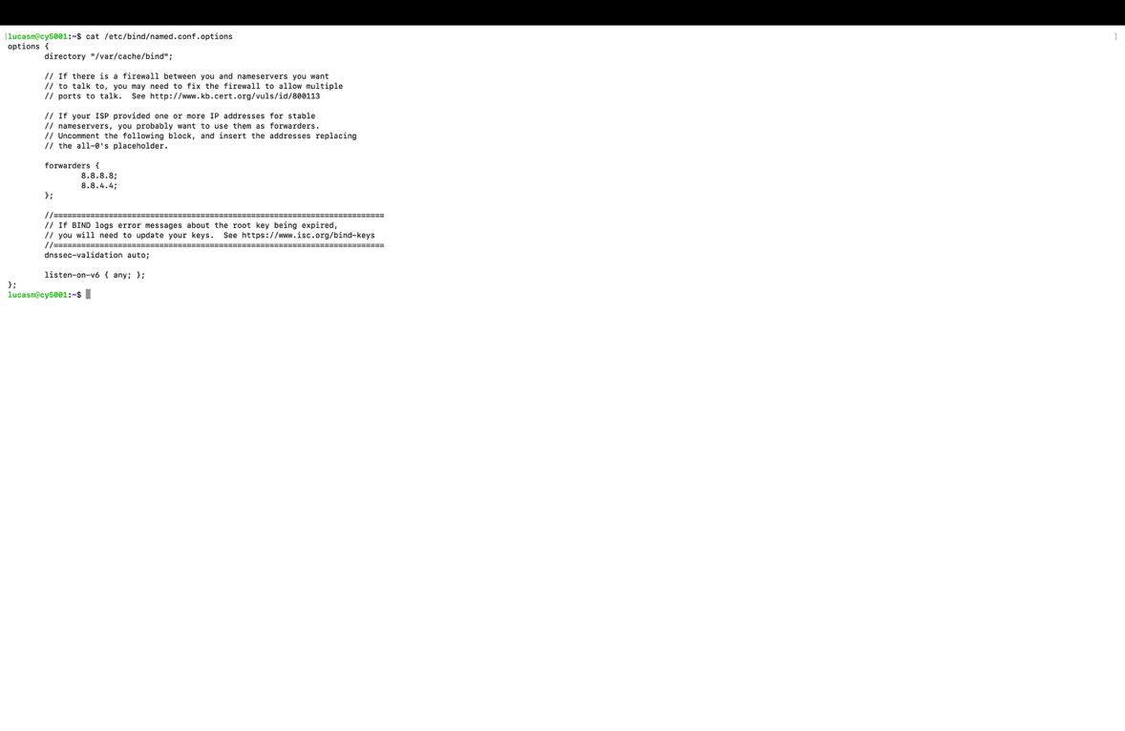
P2.2 and P2.3 screenshots
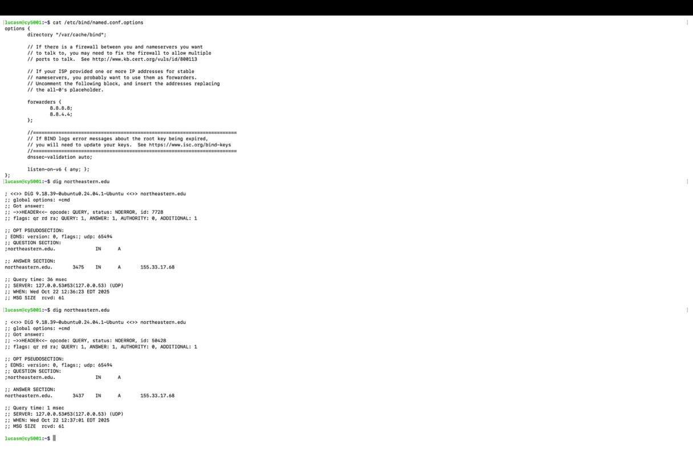
Part 3 - Setup Routing
P3.1 screenshot
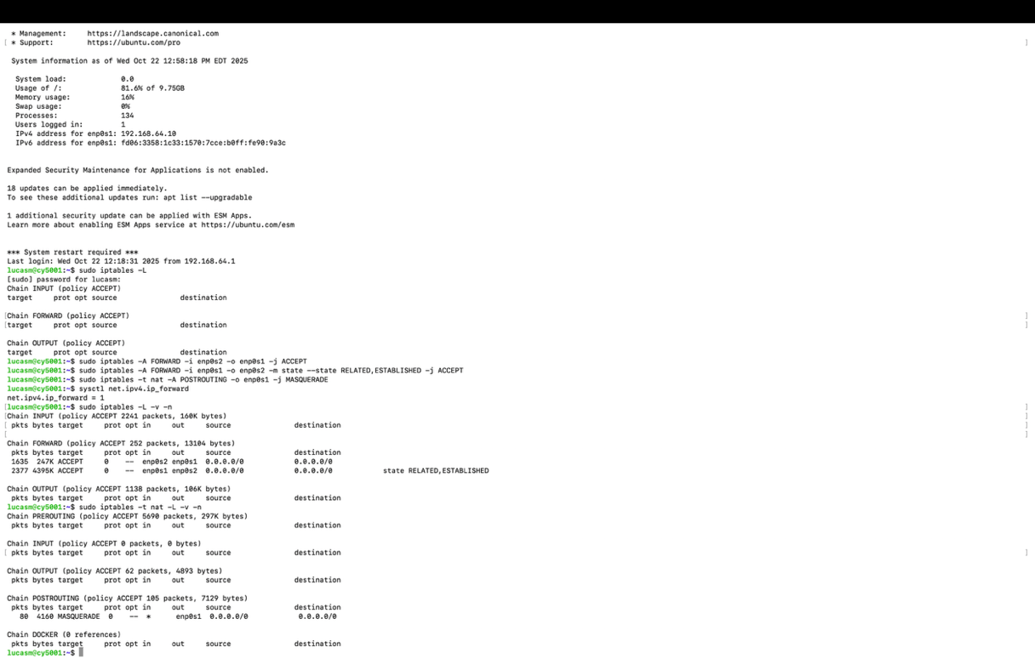

Part 4 - Setup Firewall
P4.1 screenshot
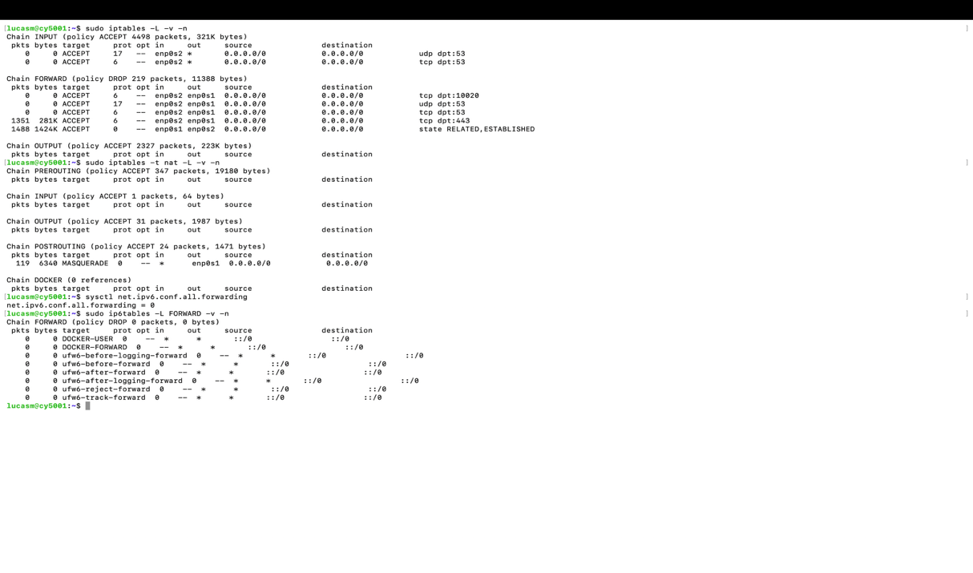

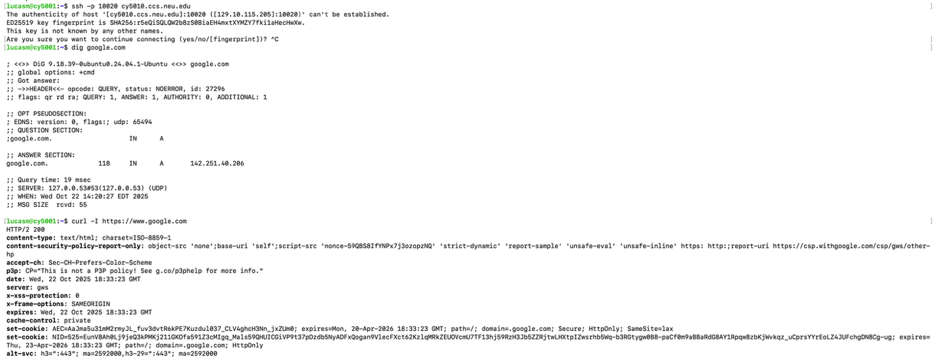

P4.2 screenshot
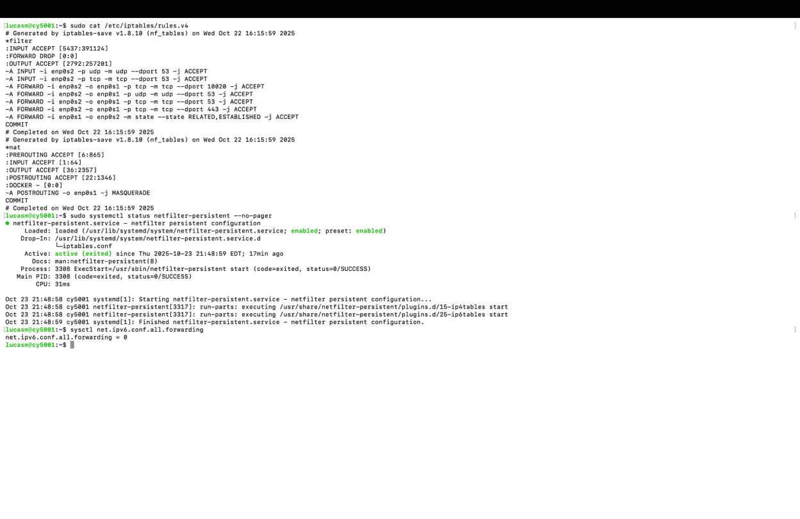

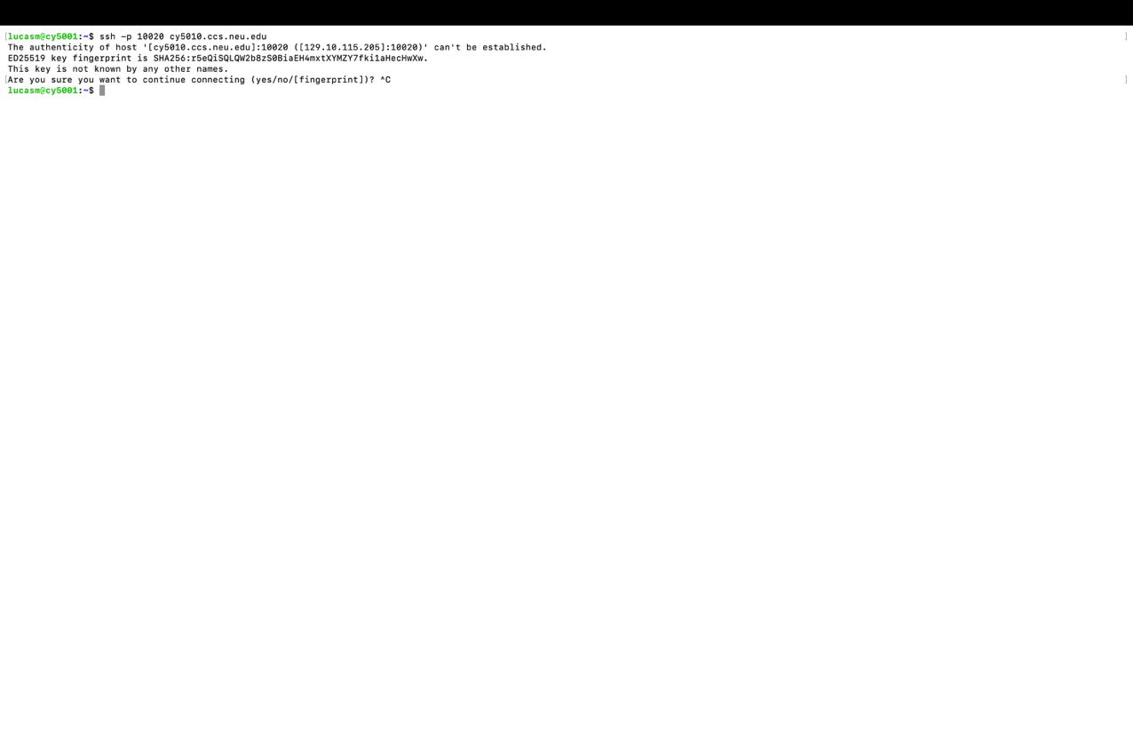

Pat 5 – Advanced firewall-Proxy Configuration
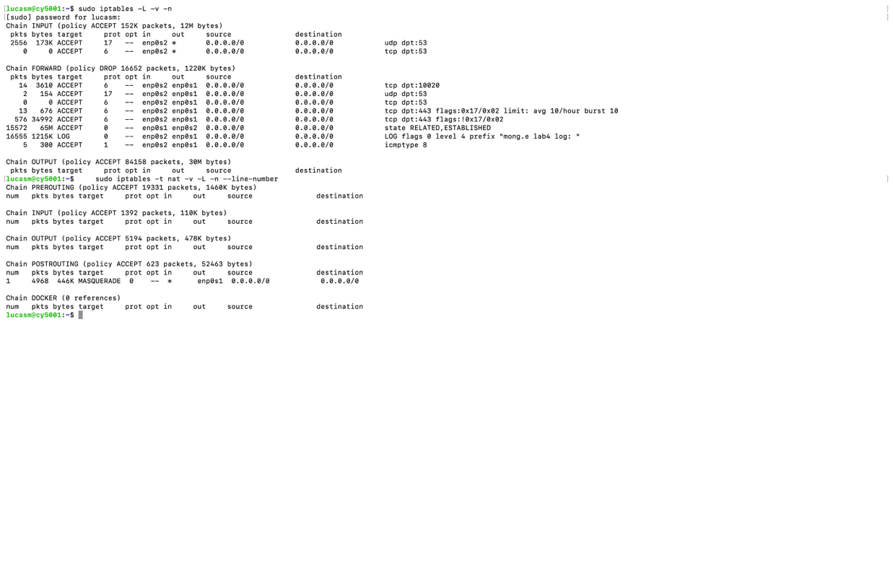

Part 6 – Testing
- SSH Connection Verification(4a) P6.1
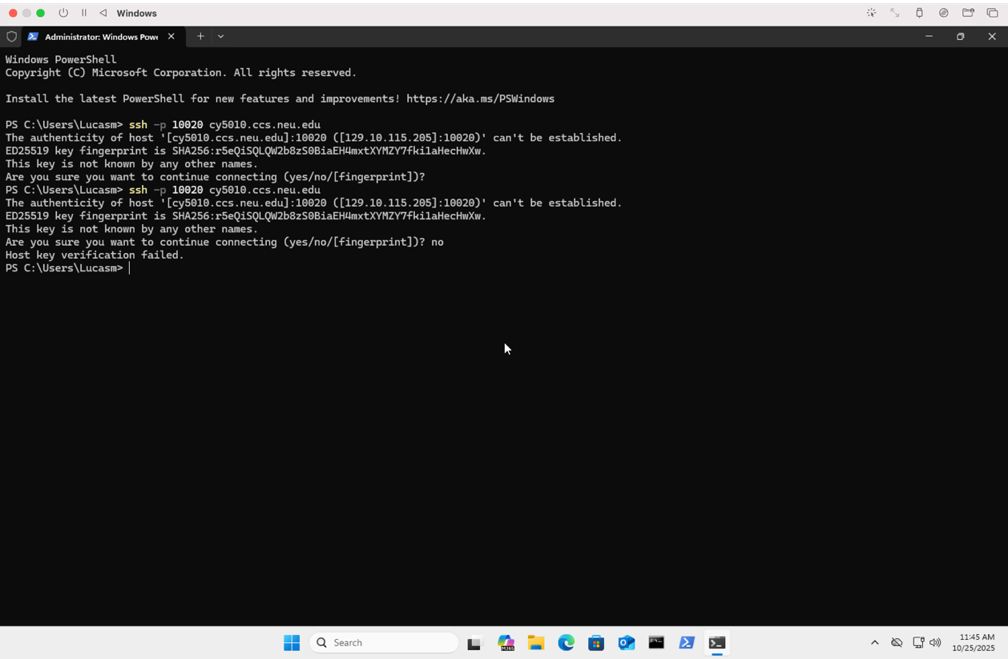
- Selective Port Access Verification (4a) P6.2
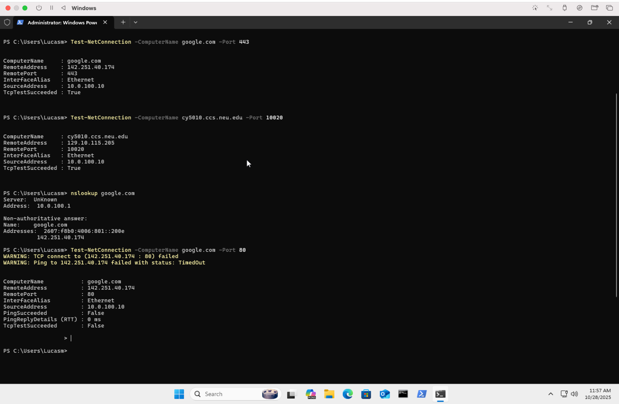
- Rate Limiting Test (5e) P6.3
DNS
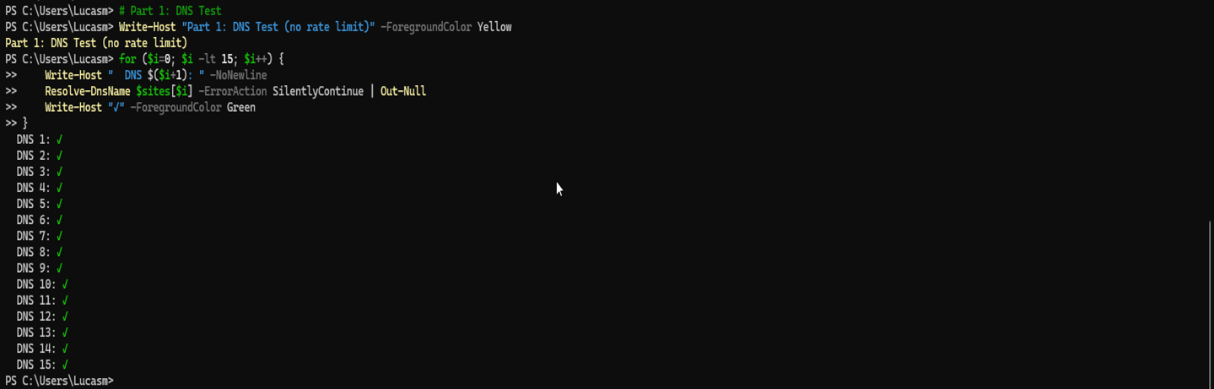

HTTPS
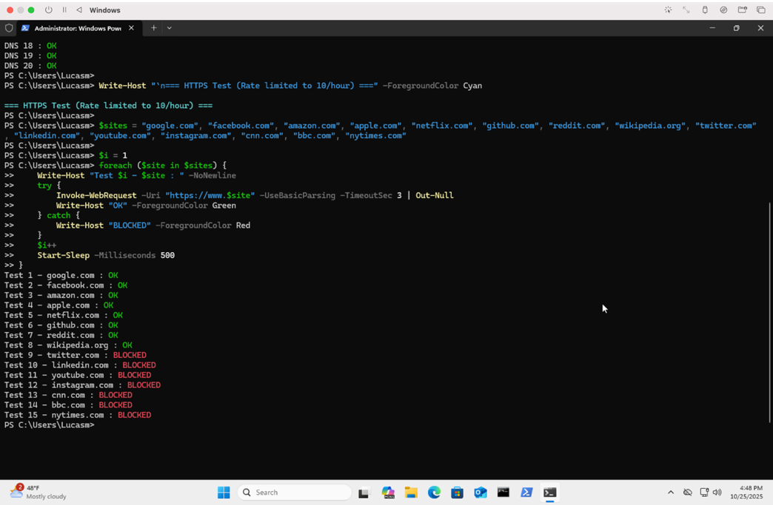
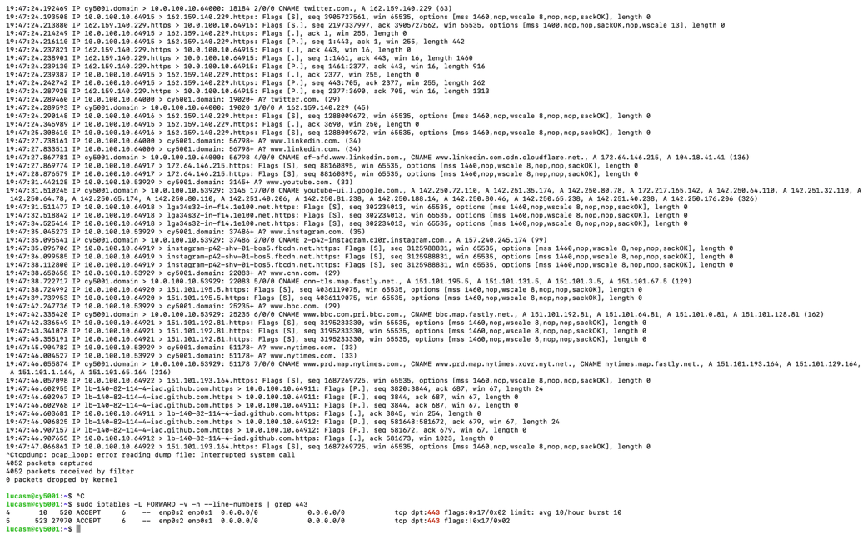
Explanation for Rate Limiting Results:
I tested rate limiting by sending 15 rapid DNS and HTTPS requests from Windows. DNS requests all succeeded (no rate limiting applied), while HTTPS requests showed 8 successes before blocking began. The rate limit was configured for 10 HTTPS connections per hour, but Windows background services (Windows Update, telemetry, OneDrive) consumed approximately 2 connection slots before my test started. This resulted in 8 manual requests succeeding, with the remaining 7 blocked, totaling the 10-connection limit. The tcpdump capture confirms DNS traffic flowed unrestricted while HTTPS connections beyond the limit showed SYN packets with no replies, proving the rate limiting works correctly.
- ICMP Control Test (5f) P6.4
